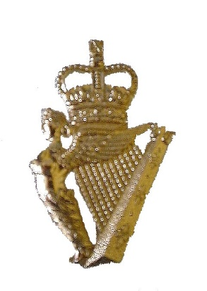

The Ulster Defence Regiment Benevolent Fund
Anderson House
Holywood
BT18 9QA
Telephone: 07720677838

01 June 2023

Dear UDR Veteran,

The Trustees of The UDR Benevolent Fund are conscious that many UDR Veterans are experiencing health issues which have resulted in them being placed on NHS waiting lists to seen by a consultant.

To try and help, the Trustees set-up a pilot health care scheme.

The pilot scheme is being reviewed at present and the Trustees are considering the possibility of extending it for a further year to 31 August 2024.

If the scheme is extended for a further year and you are not currently part of it, but would like to join, please complete the attached “Expression of Interest” form and return, preferably by email, or post, to be received no later than 13:00hrs on Friday 07 July 2023

If you are currently on the pilot, you do not need to re-apply.

The headline benefits include:

- £500 annually towards the cost of consultants’ fees (Consultant to be arranged by Westfield Health)
- £50 annually towards both dental and optician fees
- £100 annually towards therapies

However, the following are also included:

- DoctorLine™ – 24/7 virtual GP consultation service, with prescription if required
- 24/7 advice and information Line – Legal, debt and health advice and speak to a counsellor
- My Healthy Advantage App – Proactive health and wellbeing content and tools
- MRI, CT and PET Scanning Services – Quick diagnosis from a high-quality scan
- Best Doctors® – Peace of mind through an expert second medical opinion
- Wellbeing Plan – Live healthier with online health and wellbeing resources
- Westfield Rewards – Save money with offers from hundreds of leading retailers
- Gym Discounts – Discounts at leading gyms and health clubs nationwide

The pilot scheme does not cost the Veteran anything, as the monthly premium is paid by the Benevolent Fund.

To register your interest please complete the attached “Expression of Interest” document and return via email to udrbenfund@outlook.com or post to The UDR Benevolent Fund, Anderson House, Palace Barracks, Holywood Co. Down, BT18 9QA.

Brian Kennedy

Brian Kennedy
Secretary
UDR Benevolent Fund
Anderson House
Palace Barracks
Holywood
Co. Down
BT18 9QA

Mob : 077 20677838 (Office)
Email : udrbenfund@outlook.com (Office)

Health Scheme – Expression of Interest
Name

Address

(Including Post Code)

Telephone
Email

Date of Birth |  | Gender | Male |  |  | Female
Service No. |  | Battalion
Personal Declaration
I served as a member of The Ulster Defence Regiment (Please tick the box) - Proof of Service may be required - A false declaration will result in you becoming liable for any premiums paid on your behalf under legal recourse.
Data Protection
I agree to The UDR Benevolent Fund sharing the above
information with the Health Scheme provider; and retaining
the contact details for the annual update of scheme records.

I also undertake to advise The UDR Benevolent Fund should
my contact details change (Please tick the box) – Details of The UDR Benevolent Fund Data Protection policy can be found in the attached document

Pilot Scheme
I wish to take part in the pilot scheme (Please tick the box)
Date:

